Fast Surface-Mesh Projected-Density Simulation for Low-q Single-Shot XFEL Diffraction: Validation, Benchmarking, and Public-Data Template Retrieval
M. Kimª M, Hwangª, H. Jeonª, J. Seo^{a, *}
ª Department of Chemistry, Pohang University of Science and Technology (POSTECH), 77 Cheongam-ro, Nam-gu, Pohang, Gyeongbuk 37673, Republic of Korea

A surface-mesh projected-density kernel is validated for fast low-q single-shot XFEL forward simulation and tested with analytical references, performance benchmarks, and public CXIDB nanoparticle and GroEL data.
Rapid low-q forward simulation is useful for morphology screening, orientation-library construction, and candidate-model testing in single-shot XFEL diffraction, but analytical form factors are limited to ideal shapes and dense voxel or three-dimensional FFT approaches can be expensive when only a detector-plane region is required. We present a sample-level method that represents particles as oriented triangular surface meshes. For each orientation, signed surface-depth rasterization produces a projected-density image, and a chirp z-transform samples low-q detector-plane amplitudes without constructing a full reciprocal-space volume. The implementation was validated using spheres, ellipsoids, boxes, polyhedra, and scalar-field objects. These tests checked projected-density accuracy, projected-mass conservation, mesh-resolution convergence, and sampling. Representative projected-density and intensity errors were at or below the 10⁻³ level, and the analytical box comparison gave a relative intensity error of 4.07 x 10⁻⁵. Benchmarks confirmed the reduction from dense O(N³) voxel storage to projected-image O(N²) storage plus compact mesh data. For CXIDB ID57 nanoparticle patterns, a fixed 240-orientation core-shell library recovered all synthetic queries and outperformed a radial-profile-preserving randomized control for all 209 public experimental frames, with median log-correlation scores of 0.724752 and 0.443121. A GroEL case converted public PDB structure 1SS8 into a smooth density grid, isosurface meshes, decimated assemblies, and a 429-template D7 library. Because the GroEL templates showed only a small advantage over a radial control, this case is interpreted as protein-density modeling and scalability rather than high-confidence orientation retrieval. The framework provides a reproducible, geometry-general kernel for low-q single-shot diffraction workflows.
single-particle imaging; low-q XFEL diffraction; projected-density simulation; surface-mesh methods

- Introduction
Single-shot diffraction with X-ray free-electron lasers provides a way to observe individual particles, droplets, nanoparticles, viruses, and macromolecular complexes under ultrashort-pulse conditions (Neutze et al., 2000; Chapman et al., 2006; Seibert et al., 2011; Ekeberg et al., 2024). In many experiments, the measured detector image contains low-q information about particle size, projected shape, approximate orientation, and coarse morphology, even when it is insufficient for unique three-dimensional reconstruction (Loh & Elser, 2009; Ekeberg et al., 2015; Ayyer et al., 2016). Fast forward simulation is therefore useful for morphology screening, orientation-library generation, synthetic-data construction, and validation of analysis workflows.
The interpretation of a single low-q diffraction image is intrinsically ambiguous. Detector gaps, beamstop masking, photon-counting noise, fluence variation, background scattering, and unknown orientation all reduce the information available from one shot, and different three-dimensional objects can produce similar two-dimensional low-q projections. A practical goal is therefore not to infer a unique structure from one image, but to test whether a physically plausible candidate model can reproduce the dominant measured features. This requires a forward model that can be evaluated repeatedly over candidate structures, sizes, density contrasts, and orientations.
Several forward-modeling strategies are available. Analytical form factors are efficient for simple objects such as spheres, ellipsoids, cylinders, and shells, but they do not naturally cover arbitrary shapes (Feigin & Svergun, 1987). Atomistic or bead-based calculations can represent detailed molecular structures, but repeated evaluation over large orientation libraries can be costly (Hantke et al., 2016; Yoon et al., 2016). Dense voxel grids and three-dimensional FFT approaches are flexible, but they often allocate a full reciprocal-space volume when only a selected low-q detector-plane region is needed (Hantke et al., 2016; Yoon et al., 2016; Fortmann-Grote et al., 2017). Full source-to-detector simulation frameworks remain essential when pulse propagation, sample damage, detector response, photon statistics, and background are part of the question, but they can be heavier than necessary for rapid sample-level pattern generation (Yoon et al., 2016; Fortmann-Grote et al., 2017).
This work addresses the intermediate problem of fast, geometry-general, sample-level forward simulation. The aim is to convert a candidate particle morphology and orientation into an ideal low-q detector-plane intensity pattern, while leaving beamline-specific detector response, fluence normalization, photon statistics, and background modeling to subsequent workflow layers. The method is intended as a compact particle-scattering kernel that can be embedded in larger analyses, not as a replacement for complete experimental simulation.
We use oriented surface meshes as the central representation. A closed, consistently oriented triangular mesh defines the boundary of a uniform or piecewise-uniform density domain. In the low-q projection regime, the projected electron-density contrast is proportional to the path length through the object along the incident-beam direction. Instead of filling the particle with voxels or point scatterers, the method computes this projected density by signed surface-depth rasterization, where each projected mesh face contributes a depth term with a sign determined by the orientation of its outward normal relative to the beam direction. The projected-density image is then transformed to detector-plane scattering amplitudes using a chirp z-transform. The workflow is summarized in Figure 1.
This representation covers a broad morphology domain. Analytical reference shapes can be meshed for validation, polyhedral and multiple-object models can be simulated without deriving new form factors, scalar-field objects can be converted to triangular surfaces by iso-surface extraction, and composite objects can be represented as linear combinations of mesh-defined density domains. Protein-scale density models can also be approximated by constructing smooth electron-density fields from atomic coordinates and extracting isosurfaces at selected density levels.
An important requirement of the present study is reproducibility without private experimental data. Earlier versions of this project were motivated partly by experimental droplet images, including coned or deformed droplets, but those data are not used as public validation data here. Instead, the validation strategy is organized around analytical references, synthetic shape tests, performance benchmarks, and public CXIDB datasets (Maia, 2012). This makes the numerical and application-level claims reproducible by other researchers and suitable for distribution through a public code repository.
The validation is organized in three levels. First, numerical tests compare projected densities and scattering intensities with analytical or high-precision references for spheres, ellipsoids, boxes, polyhedral objects, and scalar-field models. These tests check projected-density accuracy, projected-mass conservation, mesh-resolution convergence, detector-plane sampling, and chirp-z-transform scaling. Second, benchmarks evaluate runtime and memory scaling with detector-plane image size, mesh complexity, orientation-library generation, and mesh construction. Third, public-data validation uses CXIDB nanoparticle data to compare a symmetry-aware template library against a radial-profile-preserving control.
As a further extension, we examine whether the same workflow can represent protein-scale electron density. A public GroEL structure is converted into a smooth density approximation, isosurfaces are extracted, and model assemblies are generated using mesh replication and symmetry-aware orientation sampling (Chaudhry et al., 2004; RCSB Protein Data Bank, 2005; Ekeberg et al., 2024). This part of the work is not presented as high-confidence orientation retrieval from single GroEL shots; rather, it tests whether protein-density-derived meshes can be handled by the same projected-density and template-generation pipeline.
The main contributions are a signed projected-density rasterization method for oriented surface meshes, its coupling to chirp-z-transform detector-plane sampling, numerical and public-data validation, extension from compact particles to protein-density-derived meshes, and organization of scripts and reduced outputs for reproducible distribution. The remainder of the manuscript describes the computational framework, validation, benchmarks, public-data applications, limitations, and conclusions.

- Computational Framework
This section describes the sample-level forward model used throughout the study. The goal is to generate ideal low-q detector-plane intensity patterns from candidate particle morphologies and orientations. The framework does not model the full source-to-detector chain; detector response, photon statistics, background scattering, fluence normalization, and beamline-specific corrections are treated as downstream layers.
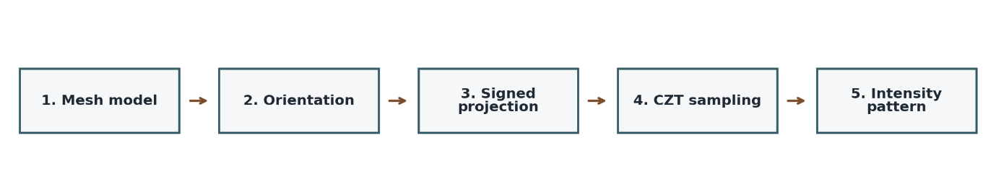
- Computational workflow for surface-mesh projected-density forward simulation. A mesh-defined candidate model is oriented relative to the incident beam, projected by signed surface-depth rasterization, sampled over the selected detector-plane q-space region with a chirp z-transform, and converted to an ideal intensity pattern. The workflow separates one-time geometry preparation from repeated orientation-dependent simulation for template-library generation, benchmark tests, and public-data comparisons.
  - Low-q projected-density forward model
Let the particle be described by an electron-density contrast distribution relative to the surrounding medium. The three-dimensional elastic scattering amplitude is
$$A(q)=\int{Δρ(r)∙e^{-iq⋅r}dr.}$$
In the low-q projection regime used here, detector-plane scattering is approximated by the Fourier transform of the projected density along the incident-beam direction (Feigin & Svergun, 1987). For beam-aligned transverse coordinates u and v and beam coordinate w,
$$T\left(u,v\right)=\int{Δρ\left(u,v,w\right)dw.}$$
The detector-plane amplitude is approximated as
$$A\left(q_{u},q_{v}\right)≈\int{T\left(u,v\right)∙e^{-i\left(q_{u}u+q_{v}v\right)}dudv.}$$
The ideal detector-plane intensity is
$$I\left(q_{u},q_{v}\right)={\left|A\left(q_{u},q_{v}\right)\right|}^{2}.$$
This approximation is intended for low-q morphology-focused modeling, where the dominant information is particle size, projected shape, anisotropy, coarse morphology, or approximate orientation. It is not a substitute for high-q coherent diffraction simulation, Finite-Ewald-sphere modeling, radiation-damage simulation, or full detector-count modeling (Feigin & Svergun, 1987).

  - Oriented surface-mesh representation
The particle boundary is represented by a closed, watertight, consistently oriented triangular surface mesh. This orientation requirement is essential because the projected-density calculation depends on a well-defined inside and outside. For a uniform-density object, the projected density is proportional to the path length through the enclosed volume along the beam direction, so the volume need not be filled with voxels or point scatterers. The boundary surface is sufficient if front-facing and back-facing contributions are accumulated with the correct signs.
The same representation can handle smooth, polyhedral, non-convex, and disconnected objects, provided that each component is closed and consistently oriented. Disconnected components are treated as separate closed volumes whose projected-density contributions add linearly, which is useful for multiple-particle illumination, composite models, and independently generated mesh components.

  - Signed projected-density rasterization
For a given particle orientation, each triangular face is transformed into the beam-aligned coordinate system and projected onto detector-plane coordinates. A face contributes to the pixels covered by its projected triangle. The contribution is proportional to face depth and has a sign determined by the face-normal direction relative to the beam.
The signed contribution can be written schematically as
$$ΔT_{p}=s_{f}∙Δρ∙z_{f}∙a_{fp},$$
where p is a detector-plane pixel, z_f is the beam-direction depth associated with face f, a_fp is the rasterized area or pixel coverage contribution, and s_f is the orientation sign:
$$s_{f}=sign\left(n_{f}⋅e_{w}\right).$$
With consistent outward normals, the signed sum over the projected surface reconstructs the projected path length through the enclosed volume. Front and back surfaces contribute with opposite signs, so the accumulated image represents projected thickness multiplied by density contrast. The implementation uses a half-open triangle edge convention to avoid double counting shared edges, and multiple face contributions are accumulated per pixel. This accumulation structure is compatible with GPU execution because projected faces and covered pixels can be processed in parallel.

  - Piecewise-uniform and composite density models
The basic formulation assumes a single uniform-density domain, but scattering amplitude is linear in density contrast. Piecewise-uniform and composite objects can therefore be represented as sums of mesh-defined volumes. If the density contrast is decomposed into M domains,
$$T(u,v)=\sum_{m=1}^{M}{Δρ_{m}L_{m}\left(u,v\right),}$$
where L_m is the projected path length through the m-th mesh-defined volume and Delta rho_m is its density contrast. Core-shell particles, inclusions, multiple particles, and density-subtraction models can be projected component by component and combined before the detector-plane transform. Smooth internal density variation can be approximated by multiple isosurfaces or nested density domains, but that introduces additional modeling choices that should be validated for each application.

  - Mesh generation from analytical, scalar-field, and density models
The framework can use meshes from several sources. Analytical shapes such as spheres, ellipsoids, boxes, cylinders, and polyhedra are useful for validation because they have analytical or high-precision references. More complex objects can be generated from scalar fields by evaluating a function on a grid and extracting an isosurface as a triangular mesh. This route supports Gaussian-blob models, smoothed polyhedra, deformed objects, and density fields derived from atomistic coordinates.
The scalar field can be written schematically as
$$φ(r)=\sum_{j}{a_{j}ψ_{j}(r; θ_{j})},$$
and the mesh is defined by
$$φ\left(r\right)=τ.$$
For localized basis functions, each contribution can be restricted to a finite support region or sigma-clipped neighborhood, avoiding unnecessary far-field evaluation. Surface extraction can be performed with marching-cubes-type algorithms or related methods such as Flying Edges (Lorensen & Cline, 1987; Schroeder et al., 2015). Extracted meshes may require orientation checks, component checks, smoothing, or decimation. Decimation is useful when the raw isosurface contains more triangles than needed for low-q simulation, but its effect should be checked by comparing mesh volume, component count, projected density, and simulated scattering patterns (Garland & Heckbert, 1997).

  - CZT-based detector-plane sampling
After the projected-density image has been computed, the detector-plane scattering amplitude is obtained by a two-dimensional transform. A standard FFT samples reciprocal space on a grid fixed by image size and pixel spacing. In contrast, the chirp z-transform allows direct sampling of a specified low-q region with flexible spacing and output size (Rabiner et al., 1969). This is useful because the detector region of interest is a two-dimensional q-space window rather than a full three-dimensional reciprocal-space volume.
For a projected-density image sampled on a regular grid, the transform can be written as
$$A(q_{u}, q_{v})≈\sum_{m,n}{T(u_{m},v_{n})∙exp[-i(q_{u}u_{m}+q_{v}v_{n})]ΔuΔv}.$$
The implementation validates the transform by checking the zero-frequency amplitude, direct-DFT agreement on small cases, q-space scaling, and the expected phase behavior under projected-density translations.

  - Orientation libraries and symmetry quotienting
For template-library generation, the particle is simulated over a set of orientations. The framework can use random rotations, deterministic grids, or precomputed rotation libraries. Rotation matrices are used during simulation because they act directly on vertices and face normals, while quaternions are useful for sampling, storage, and angular-distance calculations.
When a particle has rotational symmetry, several rotations may represent the same physical orientation. Let G be the rotational symmetry group of the object. Two rotations R_1 and R_2 are equivalent if
$R_{2}=R_{1}∙g, g∈G.$
The orientation space can therefore be reduced by quotienting out object symmetry. This avoids redundant templates and makes orientation-retrieval errors symmetry-aware. Dataset-specific details, including the CXIDB nanoparticle symmetry group and the D7 symmetry used for GroEL, are described in Section 5. Symmetry quotienting is not required for forward simulation itself, but is useful for template-library construction, retrieval comparison, and angular-error reporting.

  - Implementation workflow
The workflow separates geometry preparation from orientation-dependent projection. For each model, mesh vertices, faces, normals, density contrasts, and component definitions are prepared once. For each orientation, the mesh is transformed into the beam-aligned coordinate system, projected onto the detector plane, rasterized into a projected-density image, transformed to q-space by CZT, and converted to an intensity pattern.
This separation allows mesh generation, repair, and decimation to be performed once per model, while projection and transform steps are repeated over the orientation library. Numerical validation, benchmark timing, synthetic-library generation, public-data retrieval, and control experiments can therefore use the same forward-simulation kernel with different inputs and summaries. The main assumptions are that the mesh-defined volumes are valid, that the projected-density approximation is appropriate for the q-range of interest, and that the simulated intensity is interpreted as a sample-level ideal pattern.

- Numerical validation using analytical and synthetic references
This section tests whether the projected-density simulation kernel described in Section 2 behaves as expected under controlled conditions. The tests use analytical or synthetic reference objects only; no experimental detector frames, masks, PONI geometry files, or private morphology-specific datasets are used. The validation asks four questions: whether signed rasterization reproduces known projected densities and scattering patterns, whether projected mass is conserved across orientation, whether mesh and detector-plane refinements converge, and whether the chirp z-transform reproduces direct DFT results on a controlled grid. Table 1 summarizes the main validation metrics used to support these numerical checks.
- Numerical validation summary for analytical, synthetic, and transform checks.
Relative L2 errors are dimensionless. Pattern correlation is the Pearson correlation between simulated and reference intensity images. For shape tests, the mass error is reported relative to the mesh-defined volume; for the CZT test, the reported consistency check compares the q=0 amplitude with projected mass.
Case | Reference | Proj. density rel. L2 | Intensity Rel. L2 | Pattern corr. | Mass error
Sphere | Analytical sphere | 7.969e-4 | 7.516e-4 | 0.999999981 | -5.276e-6
Ellipsoid | Analytical ellipsoid | 7.875e-4 | 7.496e-4 | 0.999999982 | -1.358e-6
Cube | Analytical box |  | 4.069e-5 | 0.999999999 | 8.378e-6
CZT | Direct DFT |  | 3.157e-13 |  | 1.496e-13

Blank entries indicate metrics that were not applicable to that validation case.
  - Validation metrics and reference quantities
For each reference object, projected density, detector-plane amplitude, and intensity were compared with analytical or high-precision references. The primary error measure was the relative L2 error,
$$ε_{X}=\frac{{∥X_{sim}-X_{ref}∥}_{2}}{{∥X_{ref}∥}_{2}}.$$
This metric was applied to projected density, complex scattering amplitude, and intensity, depending on the available reference. Pattern similarity was summarized using the Pearson correlation between simulated and reference intensity images. Because the projected-density method is a mass-conserving surface accumulation scheme, the projected mass was evaluated as
$$M_{T}=\sum_{p}{T_{p}∙Δu∙Δv}.$$
For a closed uniform-density object, this value should agree with the object volume multiplied by density contrast. The zero-frequency scattering amplitude provides an independent consistency check because
$$A(0,0)=M_{T}.$$
Together, these checks separate the main numerical error sources: projected mass versus mesh volume tests signed surface accumulation, projected density versus analytical thickness tests rasterization, scattering-pattern agreement tests the combined projection and transform, and CZT-versus-direct-DFT agreement tests detector-plane sampling independently of the shape reference.

  - Analytical validation with sphere, ellipsoid, and box references
The first validation set used a sphere, a rotated ellipsoid, and a rectangular box. The sphere and ellipsoid were represented by triangular meshes generated at resolution 96, giving 36,480 faces in each case. The detector-plane projection grid was 512 by 512 pixels, and the low-q scattering grid used q_{max} = 25.0 with 257 samples along each reciprocal-space axis.
For the unit sphere, the projected-density relative L2 error was 7.97 x 10⁻⁴, the complex-amplitude relative L2 error was 4.89 x 10⁻⁴, and the intensity relative L2 error was 7.52 x 10⁻⁴. The intensity-pattern correlation with the analytical reference was 0.999999981. The projected mass was 4.186899, compared with an analytical volume of 4.188790 and a mesh volume of 4.186921. Thus the projected mass differed from the analytical sphere volume by -4.51 x 10⁻⁴, but from the mesh volume by only -5.28 x 10⁻⁶. This distinction matters because the finite triangular mesh is itself a discretized approximation to the smooth analytical sphere.
The ellipsoid test used semi-axes 1.0, 0.65, and 0.42 with a nontrivial orientation. The projected-density, complex-amplitude, and intensity relative L2 errors were 7.88 x 10⁻⁴, 4.53 x 10⁻⁴, and 7.50 x 10⁻⁴, respectively, with an intensity-pattern correlation of 0.999999982. The projected mass was 1.143028, compared with an analytical volume of 1.143540 and a mesh volume of 1.143030. The projected mass therefore differed from the analytical volume by -4.47 x 10⁻⁴, but from the mesh volume by only -1.36 x 10⁻⁶.
The box test provides a complementary reference because the object is exactly polyhedral and can be represented by only 12 triangular faces. For a box with half-lengths 1.0, 0.72, and 0.45, the simulated intensity agreed with the analytical box intensity with a relative L2 error of 4.07 x 10⁻⁵ and a pattern correlation of 0.999999999. The projected mass was 2.592022, compared with an analytical and mesh volume of 2.592000, giving a relative mass error of 8.38 x 10⁻⁶. A separate small-grid divergence-form check gave a complex-amplitude relative L2 difference of 6.92 x 10⁻¹⁴, confirming internal consistency of the polyhedral surface contribution.
Together, these tests show that the kernel reproduces analytical low-q references to better than 10⁻³ for smooth meshed objects and substantially better for the exact polyhedral box case. The smooth-object error is dominated by finite mesh and raster-grid approximation rather than by a failure of the signed accumulation rule, as shown by the much smaller projected-mass error relative to the actual mesh volume. Figure 2 visualizes the analytical validation cases by comparing simulated intensities, reference intensities, and residual maps.
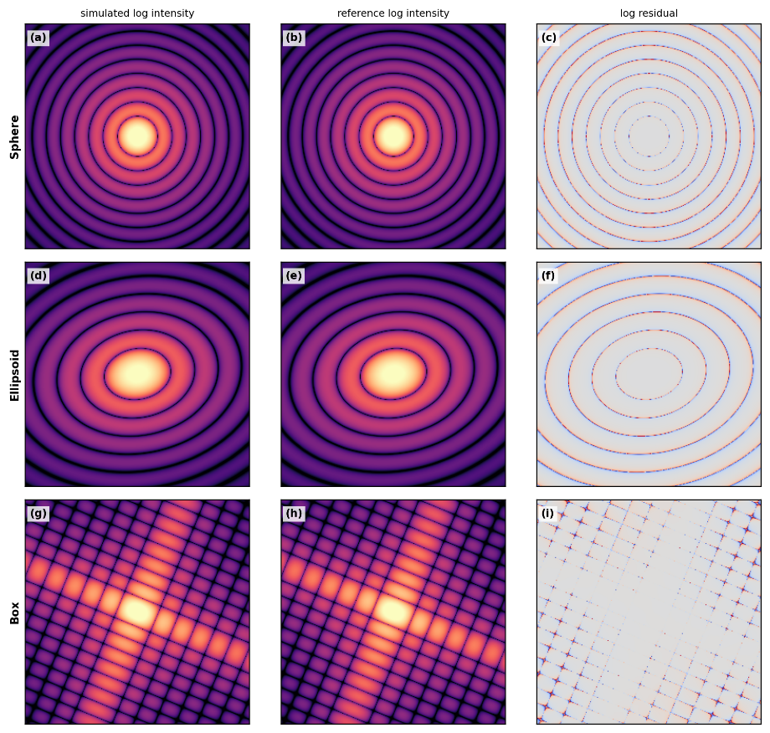
- Analytical validation of projected-density scattering patterns. Rows show the sphere, rotated ellipsoid, and polyhedral box validation cases. For each object, the panels compare the simulated intensity display, the analytical or reference intensity display, and the residual map. The sphere and ellipsoid test smooth meshed objects, whereas the box tests an exactly polyhedral object represented by the mesh itself Projected-mass conservation across orientation
The signed-rasterization method should preserve total projected mass for any orientation of a closed, consistently oriented mesh. This was tested by rotating a sphere, an ellipsoid, a box, and an icosahedron, giving 800 orientation cases in total.
When projected mass was compared with the corresponding mesh volume, the maximum absolute relative errors were 1.18 x 10⁻⁵ for the sphere, 4.07 x 10⁻⁵ for the ellipsoid, 7.07 x 10⁻⁵ for the box, and 1.03 x 10⁻⁴ for the icosahedron. Mean errors relative to mesh volume were close to zero for the box and icosahedron and were -1.65 x 10⁻⁶ for the sphere and -7.93 x 10⁻⁶ for the ellipsoid. These values indicate that front-facing and back-facing surface contributions cancel correctly across rotations and that no orientation-dependent mass drift is introduced.
The smooth sphere and ellipsoid show larger systematic errors when compared with ideal analytical volumes, with maximum absolute errors of 6.54 x 10⁻⁴ and 6.83 x 10⁻⁴, respectively. This is expected because the finite mesh volume differs slightly from the exact smooth-body volume. For validating the projection kernel itself, the mesh-volume comparison is the stricter diagnostic because it asks whether the rasterized projection conserves the volume of the object actually being simulated.

  - Mesh and detector-plane resolution convergence
Resolution convergence was evaluated in two ways: the detector-plane image size was varied for a fixed high-resolution sphere mesh, and the ellipsoid mesh resolution was varied while the detector-plane image size was held fixed.
For the sphere detector-resolution sweep, image sizes of 128, 256, 512, and 1024 pixels were tested using a mesh with 65,024 faces. Across this range, the projected-density relative L2 error remained between 3.65 x 10⁻⁴ and 4.50 x 10⁻⁴, and the intensity relative L2 error remained between 3.08 x 10⁻⁴ and 4.25 x 10⁻⁴. The intensity-pattern correlation stayed above 0.999999993 for all detector resolutions, indicating that the selected detector-plane sampling is already stable for the low-q reference pattern.
For the ellipsoid mesh-resolution sweep, the mesh resolution was varied from 24 to 128, increasing the number of faces from 2,208 to 65,024. The projected-density relative L2 error decreased from 1.06 x 10⁻² to 4.42 x 10⁻⁴, and the intensity relative L2 error decreased from 1.19 x 10⁻² to 4.21 x 10⁻⁴. The intensity-pattern correlation increased from 0.999995514 to 0.999999994.
This convergence behavior is consistent with the analytical-shape tests. For smooth objects, the dominant error at coarse resolution comes from the finite triangular approximation to a curved surface. Increasing mesh resolution reduces this geometry error, after which the remaining differences are governed by raster-grid and transform-sampling accuracy. Figure 3 summarizes the orientation mass-conservation test and the resolution-convergence behavior.
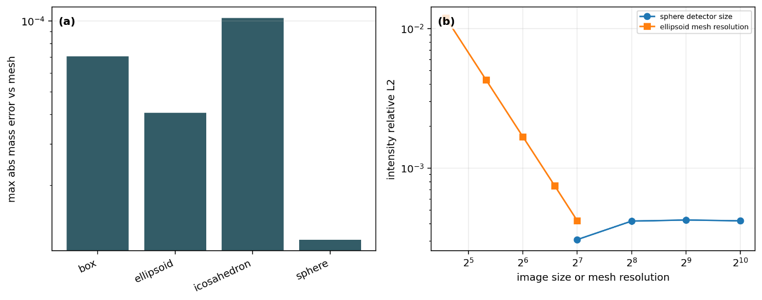
- Projected-mass conservation and resolution convergence. (a) Maximum absolute relative projected-mass error across the orientation sweep for the sphere, ellipsoid, box, and icosahedron, evaluated against the corresponding mesh volume. (b) Intensity relative L2 convergence for the sphere detector-resolution sweep and the ellipsoid mesh-resolution sweep. The trends separate mesh-geometry error from detector-plane sampling effects. Chirp z-transform and q-space sampling validation
The projected-density framework uses the chirp z-transform to sample a selected detector-plane q-space window directly (Rabiner et al., 1969). Its numerical correctness was tested by comparing the CZT result with a direct DFT calculation on a small controlled grid.
For the CZT validation case, qmax was 18.0 and the reciprocal-space grid contained 49 samples along each axis. The complex-amplitude relative L2 difference between the CZT and direct DFT was 1.65 x 10⁻¹³, and the corresponding intensity relative L2 difference was 3.16 x 10⁻¹³. These values are at numerical precision for the tested grid and show that the CZT implementation reproduces the intended discrete transform.
The same test checked phase behavior under real-space translation. After accounting for the analytical phase factor, the translated-amplitude relative L2 difference was 2.91 x 10⁻¹⁶. The translated intensity differed from the original intensity by 4.60 x 10⁻¹⁶, as expected because translation changes scattering phase but not intensity. The zero-frequency amplitude was also consistent with projected mass, with a relative difference of 1.50 x 10⁻¹³.
These checks validate detector-plane sampling independently from mesh geometry and show that the CZT does not introduce measurable q-space scaling, phase, or zero-frequency normalization errors in the tested configuration.

  - Numerical validation summary
The analytical and synthetic tests support the numerical assumptions used by the forward-simulation framework. Signed projected-density rasterization conserves mesh-defined volume across orientation, reproduces analytical projected densities and low-q scattering patterns for smooth reference objects at approximately 10⁻³ relative error, and gives substantially smaller errors for an exactly polyhedral reference object. Mesh refinement reduces the dominant smooth-object approximation error, detector-plane sampling remains stable over the tested image sizes, and the CZT implementation agrees with direct DFT to numerical precision while preserving q=0 mass normalization and translation-phase behavior.
The scope of this validation is deliberately limited. It establishes the numerical correctness of the ideal sample-level simulation kernel under controlled analytical and synthetic conditions, but does not validate detector response, photon-counting statistics, experimental background, beamline geometry calibration, or fluence normalization. The next section evaluates computational performance and memory scaling, while Section 5 tests application-level behavior using public CXIDB data and public protein-structure-derived models.

- Performance benchmarks and memory scaling
Section 3 established that the projected-density and CZT components reproduce analytical and synthetic references under controlled conditions. This section asks whether the same validated kernel is practical for repeated low-q detector-plane pattern generation. The benchmarks focus on detector-plane image size, q-space output size, mesh complexity, orientation-library generation, mesh construction, and memory cost relative to dense voxel representations.
The goal is not to report a universal hardware-independent speed. Absolute timings depend on the GPU, CPU-GPU transfer behavior, Python overhead, implementation details, and memory management. The results are used instead to identify dominant cost components and to show why the projected-density representation is useful when only a low-q detector-plane region is required.

  - Benchmark scope and environment
The benchmarks used public-safe analytical or synthetic morphologies: a sphere, an ellipsoid, a two-droplet composite object, an icosahedron, and a Gaussian-blob scalar-field object. Private deformation classes, experimental detector frames, detector masks, and beamline geometry files were excluded.
The full benchmark used the signed_raster_gpu projection backend on a Tesla T4 GPU. Each timing condition used two warm-up evaluations followed by five measured repeats. Unless otherwise stated, representative single-pattern benchmarks used a 512 by 512 projected-density image and a 257 by 257 detector-plane q-grid. The odd q-grid retained the central q=0 sample, allowing the benchmark outputs to preserve a direct projected-mass or volume-conservation check. Additional software, hardware, and timing-scope details are given in Supplementary Table S3 and Supplementary Section S5.

  - Single-pattern projection and CZT timing
Single-pattern timing separated signed projected-density rasterization from the CZT detector-plane transform. For the sphere model, increasing the projected-density image from 256 by 256 to 512 by 512 and 1024 by 1024 pixels changed the median total time from 12.66 ms to 26.01 ms and 87.89 ms. At the standard 512 by 512 image and 257 by 257 q-grid setting, the benchmark morphologies produced median total times of approximately 24 to 34 ms.
The increase with image size reflected both rasterization and transform work. For the sphere, the CZT component grew from 7.15 ms at 256 by 256 pixels to 57.16 ms at 1024 by 1024 pixels, making detector-plane transform sampling a major cost component at larger image sizes. Detailed per-size and per-morphology timing values are listed in Supplementary Section S5.

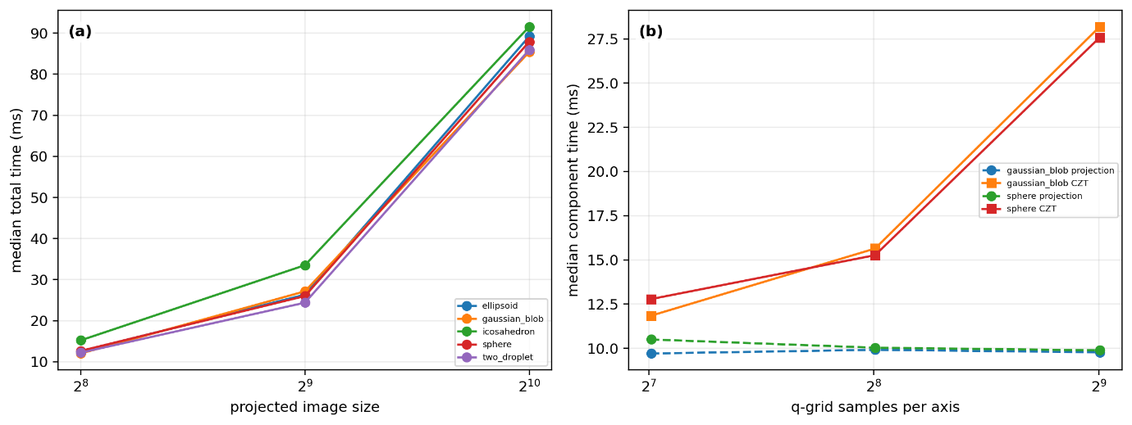
- Runtime scaling for projected-density pattern generation. (a) Median single-pattern runtime as the projected-density image size is increased at fixed 257 by 257 q-grid size. (b) Median projection and CZT times as the q-grid size is varied at fixed 512 by 512 projected-image size. The comparison shows that detector image size affects both projection and transform work, whereas q-grid size primarily increases the CZT cost.

  - q-grid scaling
The q-grid benchmark fixed the projected-density image size at 512 by 512 pixels and varied the reciprocal-space output grid. Increasing the q-grid from 129 by 129 to 257 by 257 and 513 by 513 increased median total time for the sphere from 23.28 ms to 25.27 ms and 37.47 ms. The Gaussian-blob model showed the same trend, increasing from 21.65 ms to 25.42 ms and 37.74 ms.
Thus, q-space output size primarily affects the transform stage. For template-library construction, the q-grid should match the detector region and comparison metric needed for the scientific question; oversampling beyond the useful low-q region directly increases transform cost.

  - Mesh-complexity and morphology dependence
Mesh-complexity scaling showed that face count alone did not determine runtime. At the standard detector and q-grid setting, sphere meshes from 224 to 36,480 faces all produced median total times near 24 ms, while the 65,024-face mesh increased to 34.56 ms. The morphology benchmark gave the same interpretation: the two-droplet, sphere, ellipsoid, and Gaussian-blob models were similar in timing, whereas the 20-face icosahedron was slower because its projected-fragment workload was less favorable.
These results indicate that total runtime depends on mesh size, projected pixel coverage, rasterized triangle fragments, detector image size, and CZT output size. Projected workload is therefore more informative than topology size alone.

  - Orientation-library throughput
Template-library generation repeats projection and transform evaluations over many orientations. For 1,000-orientation libraries at the standard detector and q-grid setting, all five benchmark morphologies completed without failed orientations. The total wall-clock times were approximately 151 to 160 s, corresponding to end-to-end throughputs of about 6.25 to 6.61 patterns per second.
This wall-clock throughput is lower than the single-pattern kernel timing alone would suggest. For the 1,000-orientation sphere benchmark, summed projection and CZT times accounted for 26.92 s of the measured 154.54 s wall-clock time. The remaining cost reflects Python-loop overhead, per-orientation setup, result handling, GPU synchronization, and other implementation-level overhead. The public script therefore demonstrates feasible library generation while identifying batching, reduced synchronization, and optimized orchestration as improvement targets.

- Orientation-library throughput for 1000-template benchmarks.
All rows use 512 by 512 projected-density images and 257 by 257 q-grids. Total wall time is the end-to-end library-generation time measured by the public script, whereas the inner projection-plus-CZT time is the summed kernel timing. The difference reflects Python-loop overhead, per-orientation setup, synchronization, and result handling.
Model | Orientations | Wall / s | ms / pattern | Patterns / s | Kernel sum / s
Sphere | 1000 | 154.5 | 154.5 | 6.47 | 26.9
Ellipsoid | 1000 | 157.8 | 157.8 | 6.34 | 27.7
Two droplets | 1000 | 160 | 160 | 6.25 | 27.7
Icosahedron | 1000 | 151.3 | 151.3 | 6.61 | 26.2
Gaussian blob | 1000 | 154.4 | 154.4 | 6.48 | 26.7

  - Mesh-generation cost
Mesh generation was benchmarked separately because it is usually a per-model rather than per-orientation cost. Direct analytical and component-based meshes required only a few milliseconds. Scalar-field-derived Gaussian-blob meshes were more expensive but still practical at the tested sizes, with field generation and VTK Flying Edges extraction remaining below 80 ms for the largest 160 by 160 by 160 grid.
This separation is useful for large library workflows. A candidate morphology can be generated, repaired, and stored once, after which projection and CZT are repeated over the orientation library. For scalar-field or protein-density-derived models, one-time mesh construction should therefore be reported separately from repeated pattern generation.

  - Memory-cost comparison with dense voxel approaches
The main structural advantage of the projected-density workflow is memory scaling. A dense three-dimensional voxel representation scales as O(N³), whereas the projected-density image scales as O(N²). When the output of interest is a selected detector-plane low-q region, the projected-density workflow avoids allocating unused three-dimensional reciprocal-space volume.

For a 512 grid, a dense float32 voxel volume requires 512 MB and a dense complex64 volume requires 1,024 MB. In contrast, a 512 by 512 projected float32 image requires 1 MB and a projected complex64 image requires 2 MB. Mesh arrays add memory cost, but the tested mesh-array estimates remained in the megabyte range rather than the gigabyte range. Additional memory values are given in Supplementary Section S5.
This comparison does not mean that the projected-density method replaces full three-dimensional diffraction simulation. Dense voxel and three-dimensional FFT approaches remain appropriate when volumetric reciprocal-space sampling, high-q structure, or a more complete wave-optical model is required. The advantage shown here is specific to repeated generation of ideal low-q detector-plane patterns from candidate morphologies.
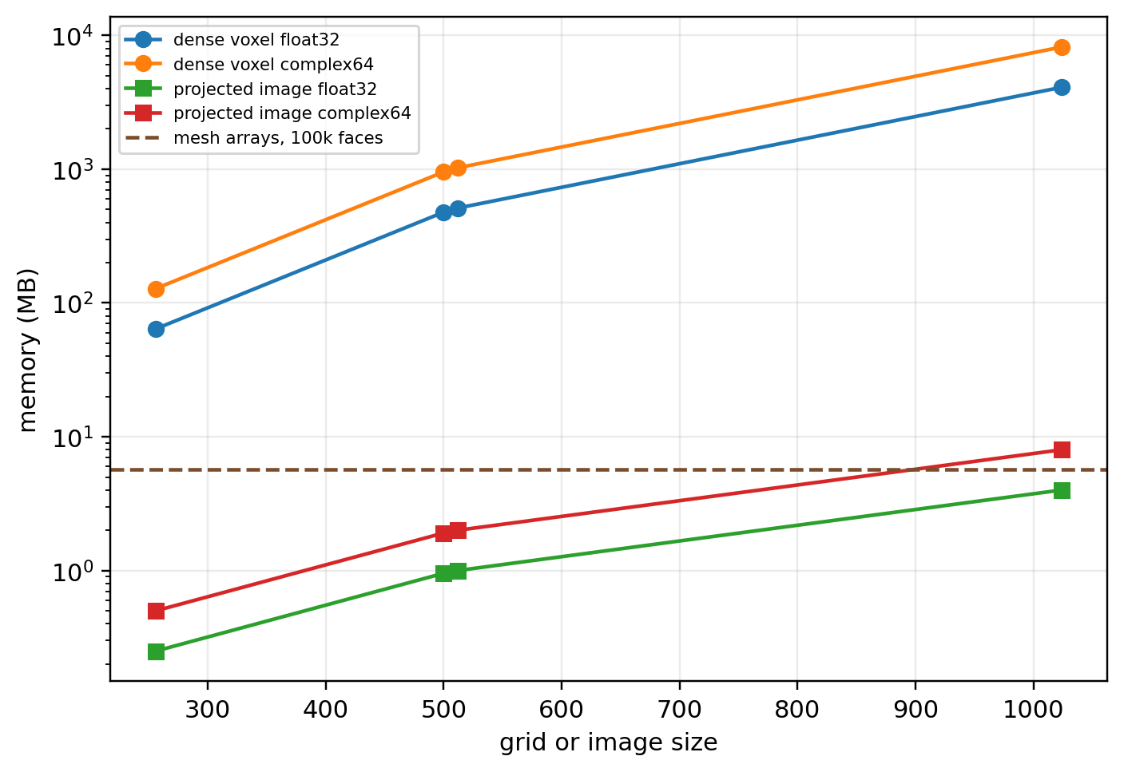
- Memory-cost comparison between dense three-dimensional arrays and the projected-density representation. Dense float32 and complex64 voxel volumes scale as O(N³), whereas projected float32 and complex64 detector-plane arrays scale as O(N²). Estimated mesh-array costs for representative vertex and face counts are included to show that mesh storage remains small compared with dense three-dimensional voxel allocation at the tested grid sizes.

  - Performance summary
The benchmarks show that the validated projected-density kernel is practical for repeated low-q pattern generation on the tested GPU system. Representative single-pattern generation at 512 by 512 pixels and a 257 by 257 q-grid required approximately 24 to 34 ms across the benchmark morphologies. Detector image size and q-grid size increased runtime as expected, with CZT becoming a major cost component at larger output grids.
End-to-end 1,000-orientation library generation was feasible, but the current public script showed substantial wall-clock overhead beyond the summed projection and CZT times. This is an implementation-level optimization opportunity rather than a limitation of the numerical kernel itself. The clearest structural result is memory scaling: when only a detector-plane low-q region is required, the workflow avoids the O(N³) cost of dense voxel sampling and instead uses O(N²) projected images plus compact mesh arrays.
These results define the computational scope for the application-level studies in Section 5. The method is best suited to workflows that require many ideal sample-level low-q patterns for screening, template-library construction, retrieval tests, or control comparisons, while leaving detector response and experiment-specific count modeling to separate layers.

- Public-data application and protein-density modeling
Sections 3 and 4 evaluated numerical accuracy and computational cost under controlled analytical and synthetic conditions. This section tests the same workflow in reproducible public-data settings. The aim is not to claim unique three-dimensional structure determination from individual low-q shots, but to ask whether structured candidate models explain dominant detector-plane features better than controls, and whether the mesh workflow extends to protein-density-derived models.
The first part uses CXIDB ID57 nanoparticle data as the main retrieval-oriented validation case, with synthetic self-retrieval, public experimental retrieval, and a radial-profile-preserving randomized control. The second uses GroEL as a protein-density modeling demonstration. The GroEL case is not treated as a stringent single-shot orientation-retrieval benchmark.

  - Public-data validation strategy
Single-shot low-q diffraction images are ambiguous because orientation, detector coverage, beamstop masking, background scattering, photon statistics, and fluence variation all affect the measurement. The validation question is therefore whether a physically motivated candidate library reproduces measured low-q features better than a control library that preserves simpler intensity statistics.
Experimental images and templates were compared inside masked annular ROIs using log1p-transformed intensities. For each frame-template pair, the template was linearly scaled with a constant background term before scoring. The primary score was normalized log-intensity correlation, with residual log-z RMS as a complementary fit-error measure. These scores compare candidate libraries but do not prove that a top-ranked template is the true orientation, because experimental orientation ground truth is unavailable.
The control strategy tested information beyond the radial intensity envelope. In both ID57 and GroEL, radial-profile-preserving randomized templates were generated by permuting pixel values within one-pixel radial bins inside the active annular ROI. The structured and control libraries then used the same masks, ROI, transform, and fitting procedure, so a real-versus-control separation measures angular or model-specific information rather than a preprocessing advantage.

  - CXIDB ID57 nanoparticle data and template construction
The first public application used CXIDB ID57 normal-incidence nanoparticle patterns. The public CXI file contained 209 detector images of size 401 by 401 pixels. A fixed core-shell candidate model was used: an outer Pd cube shell with side length 52.0 nm and an inner Au octahedral core with vertex radius 26.2 nm. The relative density contrasts were 1.0 for Pd and 1.5 for Au.
The simulation used the public detector geometry and a 384-pixel projection grid. The orientation library contained 240 symmetry-aware rotations sampled over a small normal-incidence tilt cap with proper octahedral/cubic symmetry reduction. These model and simulation parameters were fixed before experimental retrieval; only the per-template intensity scale and constant background term were fitted. Additional dataset metadata, simulation settings, and retrieval-control parameters are summarized in Supplementary Table S2.
- CXIDB ID57 public-data and retrieval-summary metrics.
The table summarizes the public detector-frame count, detector size, reconstructed q-range, fixed orientation-library size, noisy synthetic self-retrieval accuracy, and structured-versus-radial-control retrieval results for the 209 public experimental frames. Synthetic exact accuracy refers to exact clean-template index recovery for noisy synthetic queries. Real and control scores are best normalized log-intensity correlations after matched masking, ROI selection, log1p transform, and scale/background fitting.
Item | Value
Experimental frames | 209
Detector image size | 401 x 401
q_{max} / nm⁻¹ | 1.68
Orientation templates | 240
Synthetic exact accuracy | 1.00
Synthetic median logcorr | 0.967
Real median logcorr | 0.725
Control median logcorr | 0.443
Real better count | 209 / 209
Sign-test p-value | 2.43e-63

  - Synthetic self-retrieval check for ID57
Before experimental retrieval, the pipeline was tested using noisy synthetic queries generated from the same 240-orientation library and clean templates as the reference library. This checks masking, log-intensity scoring, scale/background fitting, and symmetry-aware indexing under known-orientation conditions.
All 240 noisy synthetic queries retrieved the correct clean-template index, giving exact-index accuracy 1.0. The median log-correlation score was 0.966886, and the symmetry-aware octahedral error was 0 degrees for the median, 95th percentile, and maximum. This check confirms recovery of known library members under realistic noise and masking, but it does not by itself validate the experimental interpretation because the query and library share the same generative model.

  - Retrieval against public ID57 experimental frames
The structured ID57 library was then evaluated against all 209 public experimental frames and compared with the radial-profile-preserving randomized control. Because the control library was generated by radial-bin scrambling of the same template stack, each paired comparison used matched detector geometry, template count, ROI, and scoring procedure.
The structured library clearly outperformed the radial control. Across 209 paired comparisons, the structured median log-correlation score was 0.724752, while the radial-control median was 0.443121. The structured library scored higher in all 209 of 209 frames, with a two-sided sign-test p-value of 2.43 x 10⁻⁶³. The residual metric gave the same conclusion: the structured template had lower residual in all paired comparisons.
These results support the application-level ID57 validation claim. The structured core-shell library is not merely matching an average radial envelope; it captures model-specific two-dimensional low-q features present in the public images. Because individual-frame ground-truth orientations are unavailable, the result should not be interpreted as proof that every top-ranked template is the true orientation.
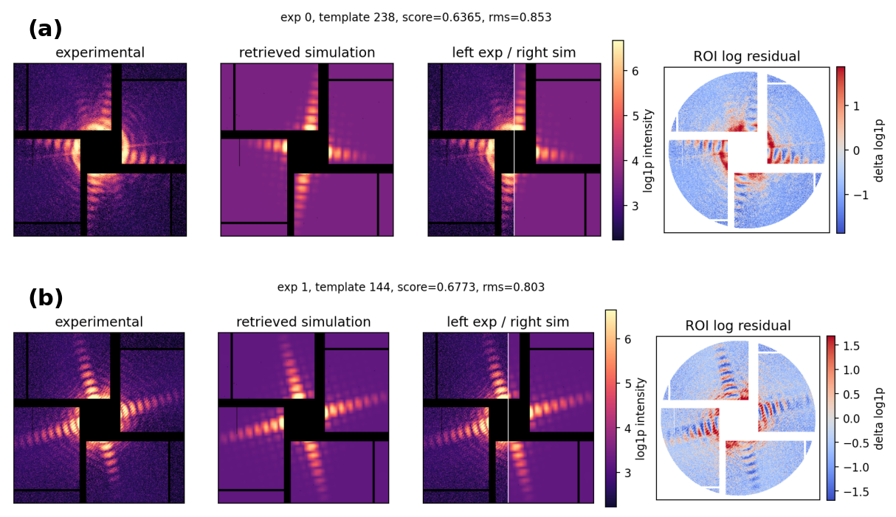
- Representative retrieval examples from public CXIDB ID57 experimental frames. Each row shows one experimental frame, the best-matching structured core-shell template, a left-experiment/right-simulation composite, and the ROI log-residual map after per-template scale and background fitting. These examples illustrate the visual agreement of the fixed template library with selected public frames, but they do not establish ground-truth orientation recovery for individual shots.
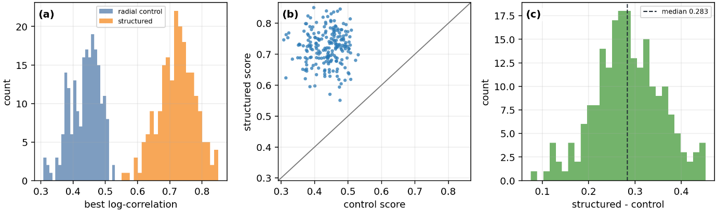
- Structured-library versus radial-control retrieval scores for the 209 public CXIDB ID57 experimental frames. (a) Distribution of best normalized log-intensity correlation scores for the structured core-shell library and the radial-profile-preserving randomized control. (b) Paired frame-by-frame score comparison. (c) Distribution of paired score differences, defined as structured minus control. The structured library outperformed the radial control for all 209 frames, indicating that the candidate model captures two-dimensional low-q features beyond the radial intensity envelope.
Additional representative ID57 retrieval examples are shown in Supplementary Figure S2.

  - GroEL protein-density construction from a public PDB structure
The second public-data case tested extension to protein-scale density-derived mesh models. The input was public GroEL structure 1SS8. Non-hydrogen atoms were converted into a smooth electron-density approximation using Waasmaier-Kirfel-inspired Gaussian scattering-factor terms. A structural preview of the 1SS8 heptamer and BIOMT-related tetradecamer assembly is provided in Supplementary Figure S1.
The resulting density grid had 1.0 A spacing and contained 188 by 186 by 120 voxels. Its integrated density was consistent with the expected electron count from the atom-derived model, supporting its use as a practical protein-scale density representation. Element counts, density settings, grid memory, construction time, and electron-count checks are given in Supplementary Table S1.

  - GroEL isosurface meshes, assembly, and decimation
Five isosurface levels were extracted from the GroEL density field. These surfaces defined two model families: Model A, a C7 heptamer, and Model B, a D7 tetradecamer assembled by appending the BIOMT-related copy using the transform (x, -y, -z). This reused mesh components rather than reconstructing density from atoms.
The 50% threshold tetradecamer mesh was used as the representative protein-scale mesh. After quadric decimation to approximately 20% of the original mesh, component count was preserved and the maximum absolute relative volume error across the decimation summary was 1.57 x 10⁻³. Projection-level comparison against the reference density projection remained highly correlated before and after decimation. Detailed point counts, cell counts, volumes, and projection metrics are given in Supplementary Table S1.
These results show that the protein-density-derived mesh representation preserves the low-q projected-density quantities used by the framework after substantial decimation, although not necessarily all internal protein-density detail.
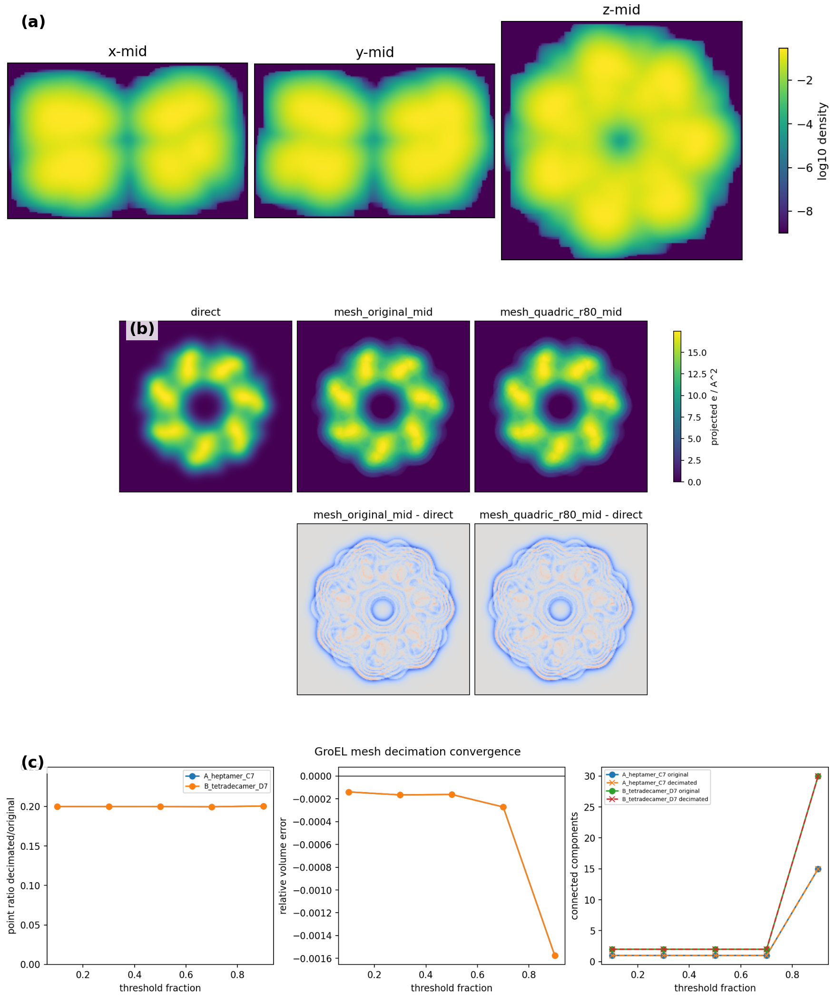
- GroEL density construction, projection validation, and mesh-decimation behavior. (a) Orthogonal mid-slices through the smoothed PDB-derived electron-density grid. (b) Comparison of the reference density projection with layer-weighted mesh/stencil projections from the original and decimated meshes, including residual maps. (c) Decimation summary showing point and cell reduction, relative volume error, and projection-level error metrics across density thresholds. The figure tests whether the protein-density-derived mesh representation preserves the low-q projected-density quantities used by the forward model.

  - GroEL template-library demonstration and radial-control check
The GroEL template library used the D7 tetradecamer model and two coarse polyprism variants representing peripheral density changes. Symmetry-aware D7 sampling reduced 201 candidate rotations to 143 representative rotations; with three variants, the final library contained 429 templates. Representative model-variant projections and preview diffraction patterns are shown in Supplementary Figure S3.
The public experimental comparison used 76 manually curated GroEL shots. The protein-derived library was slightly and consistently better than the radial-profile-preserving control, but the separation was small. This result should therefore be interpreted as a limitation-aware modeling demonstration rather than strong GroEL orientation-retrieval validation. The detailed score distribution and paired comparison are shown in Supplementary Figure S4 and summarized in Supplementary Table S1.

  - Public-data application summary
The ID57 and GroEL cases play different roles. ID57 provides the stronger retrieval-oriented public-data validation: a 240-orientation symmetry-aware core-shell nanoparticle library recovered all noisy synthetic queries exactly and outperformed a radial-profile-preserving randomized control in all 209 public experimental paired comparisons. GroEL provides a protein-density modeling and scalability demonstration: a public PDB structure was converted into a smooth electron-density grid, assembled into heptamer and tetradecamer meshes, decimated with stable projection-level behavior, and used to generate a D7 symmetry-aware template library.
Together, these studies show that the validated kernel is usable beyond analytical test objects. The method supports reproducible nanoparticle retrieval tests and can be extended to protein-density-derived models, while the control comparisons define the limits of what can be claimed from low-q single-shot data alone.

- Discussion
This work presents a projected-density forward-simulation framework for low-q single-shot diffraction patterns from mesh-defined particle models. The method represents particles as closed, oriented surface meshes, computes projected density by signed surface-depth rasterization, and samples the detector-plane q-space region using a chirp z-transform. It is not a full source-to-detector simulator; it is a sample-level scattering kernel for rapid generation of ideal low-q patterns from candidate morphologies and orientations.
The results support three conclusions. First, the numerical kernel is accurate for the tested analytical and synthetic cases. Second, the projected-density representation is computationally efficient when the desired output is a selected detector-plane low-q region rather than a full three-dimensional reciprocal-space volume. Third, the same workflow can be used in reproducible public-data applications, with ID57 providing the stronger retrieval-oriented validation and GroEL demonstrating extension to protein-density-derived meshes.

  - Role of the projected-density approximation
The projected-density approximation is useful when the scientific question concerns coarse morphology, projected shape, size, anisotropy, or approximate orientation. In this regime, the detector-plane pattern is strongly influenced by electron-density contrast integrated along the beam direction. Computing that projection directly avoids point-scatterer filling or dense three-dimensional voxel allocation when only a two-dimensional low-q detector region is needed.
This scope is also the main limitation. The method is not designed to model high-q structural detail, finite Ewald-sphere curvature, multiple scattering, pulse propagation, radiation damage, detector response, photon-counting statistics, or experiment-specific background. It should therefore be viewed as a compact particle-scattering component that can be embedded in larger workflows, not as a replacement for complete experimental simulation packages (Hantke et al., 2016; Yoon et al., 2016; Fortmann-Grote et al., 2017).
This boundary is important for interpreting the validation. Agreement with analytical form factors and public low-q patterns shows that the kernel captures the intended projected-density behavior, not that detector counts, noise distributions, fluence variation, or calibrated experimental backgrounds have been modeled.

  - Advantages of the oriented-mesh representation
The oriented surface-mesh representation gives the framework a broad geometry domain. Analytical reference shapes, polyhedra, composite particles, scalar-field isosurfaces, and protein-density-derived meshes can all be handled through the same projection interface, without deriving a new analytical form factor for each object class.
The signed rasterization step is the key numerical mechanism. With closed, consistently oriented meshes, front-facing and back-facing surface contributions reconstruct the projected path length through the enclosed volume. The validation results show that this mechanism conserves projected mass across orientations and reproduces low-q scattering references with small errors. For smooth shapes, remaining disagreement with ideal analytical volumes reflects finite mesh approximation as well as rasterization error.
The same representation supports piecewise-uniform density models. Different mesh components can carry different density contrasts, allowing core-shell particles, inclusions, multiple particles, or density-subtraction models to be simulated by linear combination. This capability was used in the ID57 model and provides a route for more complex candidate libraries.

  - Computational implications
The performance benchmarks show that the method is practical for repeated ideal low-q pattern generation in the tested GPU environment. Runtime increased with detector image size and q-grid size, and the CZT transform became a major cost component at larger output grids. Mesh face count alone was not a sufficient predictor of runtime; projected pixel coverage, rasterized fragments, image size, and q-grid size were more informative.
The strongest structural advantage is memory scaling. Dense voxel approaches allocate a three-dimensional grid even when the output of interest is a two-dimensional detector-plane region. The projected-density workflow instead uses a two-dimensional projection image, a two-dimensional q-grid, and mesh arrays, avoiding unused reciprocal-space volume and reducing memory pressure.
The orientation-library benchmarks also identify an implementation-level opportunity. Summed projection and CZT times were much smaller than end-to-end wall-clock time in the public script, indicating overhead from Python loops, synchronization, setup, and result handling. The current implementation is sufficient for reproducible validation and template construction, but batching and tighter GPU orchestration could improve throughput.

  - Interpretation of ID57 retrieval
The ID57 application is the strongest public-data validation in this study (Maia, 2012; Li et al., 2017; Coherent X-ray Imaging Data Bank, 2016). Synthetic self-retrieval confirmed that the template library, masking, scoring, and symmetry bookkeeping were internally consistent. Experimental retrieval then showed that the structured core-shell library outperformed a radial-profile-preserving randomized control for the public paired comparisons.
This supports the claim that the projected-density model captures model-specific two-dimensional low-q features in the ID57 images. The radial control is essential because it tests whether the result is merely matching an average radial intensity envelope. In ID57, the structured library performed substantially better than that control, indicating that non-radial information contributes to the score.
The result should still be interpreted as candidate-model retrieval, not proof of ground-truth orientation recovery for each shot. The public frames do not provide true orientations, and detector artifacts, background, finite sampling, and possible model mismatch remain. The appropriate conclusion is that the structured core-shell library explains the measured low-q images better than a simpler control library.

  - Interpretation of the GroEL extension
The GroEL analysis addresses a different question from ID57 (Ekeberg et al., 2024; Coherent X-ray Imaging Data Bank, 2024; Chaudhry et al., 2004; RCSB Protein Data Bank, 2005). It tests whether the mesh-based workflow extends to protein-scale density models from public structural data. Density construction, isosurface extraction, C7 and D7 mesh assembly, decimation, projection validation, and template generation show that this extension is feasible. The decimation results show that large protein-derived meshes can be reduced substantially while preserving projection-level behavior.
The retrieval comparison for curated GroEL shots should be framed cautiously. The protein-derived templates were slightly and consistently better than the radial-profile-preserving control, but the separation was small. This suggests that the tested shots are dominated by central low-q radial-envelope information, with only modest model-specific information in the selected ROI and library. GroEL should therefore not be used as the main orientation-retrieval validation case.
The value of the GroEL case is methodological. It demonstrates that public PDB-derived density can be converted into a mesh-based projected-density model and propagated through symmetry-aware template generation. It also shows why control comparisons are necessary: without the radial control, the raw GroEL correlations could be overinterpreted.

  - Reproducibility and public-data scope
A recurring goal of this study is to make the validation independent of private experimental data. The manuscript therefore uses analytical references, synthetic public-safe morphologies, performance benchmarks, CXIDB public nanoparticle data, and public protein structural data. Earlier private droplet or deformation examples are not used as evidence for the main claims, making the scope narrower but more reproducible (Maia, 2012; Li et al., 2017; Coherent X-ray Imaging Data Bank, 2016; Ekeberg et al., 2024; Coherent X-ray Imaging Data Bank, 2024; Chaudhry et al., 2004; RCSB Protein Data Bank, 2005).
The public-data strategy clarifies what each validation layer contributes. Analytical references establish numerical correctness. Synthetic self-retrieval checks implementation consistency. Performance benchmarks establish cost and memory behavior. Public-data retrieval and control comparisons test whether the workflow provides useful candidate-model information in realistic data.

Reduced output packages, CSV summaries, JSON metadata, and visual comparisons let readers inspect the evidence without rerunning every large intermediate calculation. Benchmark timing and GPU-specific behavior should still be remeasured on new hardware or deployment builds.

  - Limitations
Several limitations remain. The forward model assumes that the projected-density approximation is appropriate for the q-range and morphology question. High-q reconstruction, detailed molecular scattering, Ewald-sphere effects, detector-count modeling, fluence variation, and background modeling require additional physics. The method also assumes valid mesh geometry; open surfaces, inconsistent normals, self-intersections, or poorly chosen isosurface thresholds can produce incorrect projected densities.
The scoring and retrieval pipeline is also limited. Low-q single-shot retrieval is ambiguous, and many candidate models can produce similar detector-plane patterns. Log-correlation, annular ROIs, scale/background fitting, and radial-profile controls make the comparisons reproducible, but different ROIs, masks, q-ranges, background models, or scoring functions could change rankings.
The current implementation has performance limitations at the library-orchestration level. Single-pattern kernel timing is faster than end-to-end orientation-library wall time, showing significant Python-loop and synchronization overhead. The GPU backend also depends on CUDA through CuPy. Systems without NVIDIA CUDA support can use CPU paths, but should not expect the same acceleration without a backend redesign.
The protein-density extension has its own approximations. The GroEL density model uses smoothed atom-derived Gaussian density and isosurface layers, not a full experimental electron-density reconstruction. The polyprism variants are coarse model perturbations rather than refined structural models. The GroEL comparison therefore demonstrates pipeline feasibility and limitations, not high-confidence molecular orientation recovery.

  - Future extensions
Several extensions follow naturally from this work. Numerically, the projection kernel could be tested against additional analytical shapes, non-convex objects, multi-component density models, and higher-accuracy quadrature or rasterization references. CZT sampling could also be adapted to nonuniform detector q sampling or experimentally defined ROIs.
Performance improvements should focus on batched projection, batched CZT evaluation, reduced host-device synchronization, reusable GPU buffers, and compact result storage. A production implementation could separate one-time mesh preparation from repeated orientation updates more aggressively than the current public scripts.
Modeling extensions could add detector response, photon statistics, fluence variation, background models, and beamline-specific calibration layers around the sample-level kernel. These additions would place the projected-density model inside a more complete source-to-detector chain while retaining direct detector-plane sampling when appropriate.
Additional public datasets would strengthen validation. The most useful tests would pair structured template libraries with well-defined controls and, where possible, independent orientation or morphology information. ID57 shows the value of radial controls for nanoparticle retrieval, while GroEL shows how controls prevent overstatement when the signal is dominated by radial-envelope information.
Overall, the projected-density framework is most useful as a fast, geometry-general, reproducible forward-modeling layer for low-q single-shot diffraction. Its main strength is not that it solves every part of experimental diffraction analysis, but that it provides a compact and validated kernel for generating candidate detector-plane patterns across mesh-defined morphologies.

- Conclusion
This study developed and evaluated a projected-density forward-simulation framework for low-q single-shot diffraction patterns from mesh-defined particle models. The method represents uniform or piecewise-uniform density domains with closed, consistently oriented triangular surface meshes, computes projected density by signed surface-depth rasterization, and samples detector-plane scattering intensities using chirp z-transform sampling. The result is a compact sample-level scattering kernel for morphology screening, orientation-library generation, synthetic-data construction, and public-data comparison.
The numerical validation showed that the projection and transform operations behave as intended. Analytical and synthetic tests using spheres, ellipsoids, boxes, polyhedral objects, and scalar-field objects confirmed projected-density accuracy, projected-mass conservation, mesh-resolution convergence, and q-space sampling consistency. Smooth meshed objects agreed with analytical references at approximately the 10⁻³ relative-error level, while the exact polyhedral box case showed substantially smaller intensity error. The q=0 amplitude checks and orientation sweeps further confirmed conservation of mesh-defined projected mass.
The performance results support the practical role of the method. When the target is a selected low-q detector-plane region, the workflow avoids dense three-dimensional reciprocal-space allocation and instead uses a two-dimensional projected image, a two-dimensional q-grid, and compact mesh arrays. In the tested GPU environment, representative single-pattern generation was in the tens-of-milliseconds range. The orientation-library benchmarks also showed that additional throughput gains should be possible through batching, reduced synchronization, and tighter GPU orchestration.
The public-data applications define the main scientific scope of the framework. In CXIDB ID57, a 240-orientation symmetry-aware core-shell nanoparticle library recovered all noisy synthetic queries exactly and outperformed a radial-profile-preserving randomized control in all 209 public experimental paired comparisons. This supports the claim that the projected-density library captures model-specific low-q features beyond a radial intensity envelope, while still remaining a candidate-model validation rather than proof of ground-truth orientation recovery for individual shots.
The GroEL case showed that the workflow can be extended to protein-density-derived mesh models. A public PDB structure was converted into a smooth electron-density grid, isosurfaces were extracted, heptamer and tetradecamer assemblies were built, and decimated meshes preserved projection-level behavior. The resulting D7 symmetry-aware template library gave a small but consistent improvement over a radial control for curated public shots. This result is best interpreted as a modeling and scalability demonstration, not as high-confidence molecular orientation retrieval.
Overall, the framework fills an intermediate role between simple analytical form factors and full source-to-detector experimental simulations. It is geometry-general, reproducible with public data, efficient for low-q detector-plane sampling, and extensible from compact particles to protein-density-derived meshes. Its appropriate use is to generate and test physically motivated candidate patterns under explicit sample-level assumptions, while detector response, photon statistics, background modeling, and full experimental calibration remain separate workflow layers.

The acknowledgements should be in a single paragraph (style name: IUCr acknowledgements; this style applies the heading). The contributions of non-authors etc. should be given here.
Please declare any conflicts of interest, or declare that there are no conflicts of interest (single paragraph).
Please state how the data supporting the results reported in your article can be accessed, e.g. within the article, as published supporting material, in repositories, upon request... (single paragraph).

References
Ayyer, K., Lan, T.-Y., Elser, V. & Loh, N. D. (2016). Dragonfly: an implementation of the expand-maximize-compress algorithm for single-particle imaging. J. Appl. Cryst. 49, 1320-1335. https://doi.org/10.1107/S1600576716008165
Chapman, H. N., Barty, A., Bogan, M. J., Boutet, S., Frank, M., Hau-Riege, S. P., Marchesini, S., Woods, B. W., Bajt, S., Benner, W. H., London, R. A., Plönjes, E., Kuhlmann, M., Treusch, R., Düsterer, S., Tschentscher, T., Schneider, J. R., Spiller, E., Möller, T., Bostedt, C., Hoener, M., Shapiro, D. A., Hodgson, K. O., van der Spoel, D., Burmeister, F., Bergh, M., Caleman, C., Huldt, G., Seibert, M. M., Maia, F. R. N. C., Lee, R. W., Szöke, A., Timneanu, N. & Hajdu, J. (2006). Femtosecond diffractive imaging with a soft-X-ray free-electron laser. Nat. Phys. 2, 839-843. https://doi.org/10.1038/nphys461
Chaudhry, C., Horwich, A. L., Brunger, A. T. & Adams, P. D. (2004). Exploring the structural dynamics of the E. coli chaperonin GroEL using translation-libration-screw crystallographic refinement of intermediate states. J. Mol. Biol. 342, 229-245. https://doi.org/10.1016/j.jmb.2004.07.015
Coherent X-ray Imaging Data Bank (2016). CXI DB ID 57: Diffraction data of core-shell nanoparticles from X-ray Free Electron Laser. https://doi.org/10.11577/1345570
Coherent X-ray Imaging Data Bank (2024). CXI DB ID 187: Observation of a single protein by ultrafast X-ray diffraction. https://doi.org/10.11577/2290448
Ekeberg, T., Svenda, M., Abergel, C., Maia, F. R. N. C., Seltzer, V., Claverie, J.-M., Hantke, M., Jönsson, O., Nettelblad, C., van der Schot, G., Liang, M., DePonte, D. P., Barty, A., Seibert, M. M., Iwan, B., Andersson, I., Loh, N. D., Martin, A. V., Chapman, H. N., Bostedt, C., Bozek, J. D., Ferguson, K. R., Krzywinski, J., Epp, S. W., Rolles, D., Rudenko, A., Hartmann, R., Kimmel, N. & Hajdu, J. (2015). Three-dimensional reconstruction of the giant mimivirus particle with an X-ray free-electron laser. Phys. Rev. Lett. 114, 098102. https://doi.org/10.1103/PhysRevLett.114.098102
Ekeberg, T., Assalauova, D., Bielecki, J., Boll, R., Daurer, B. J., Eichacker, L. A., Franken, L. E., Galli, D. E., Gelisio, L., Gumprecht, L., Gunn, L. H., Hajdu, J., Hartmann, R., Hasse, D., Ignatenko, A., Koliyadu, J., Kulyk, O., Kurta, R., Kuster, M., Lugmayr, W., Lübke, J., Mancuso, A. P., Mazza, T., Nettelblad, C., Ovcharenko, Y., Rivas, D. E., Rose, M., Samanta, A. K., Schmidt, P., Sobolev, E., Timneanu, N., Usenko, S., Westphal, D., Wollweber, T., Worbs, L., Xavier, P. L., Yousef, H., Ayyer, K., Chapman, H. N., Sellberg, J. A., Seuring, C., Vartanyants, I. A., Küpper, J., Meyer, M. & Maia, F. R. N. C. (2024). Observation of a single protein by ultrafast X-ray diffraction. Light Sci. Appl. 13, 15. https://doi.org/10.1038/s41377-023-01352-7
Feigin, L. A. & Svergun, D. I. (1987). Structure Analysis by Small-Angle X-ray and Neutron Scattering. New York: Plenum Press.
Fortmann-Grote, C., Buzmakov, A., Jurek, Z., Loh, N. T. D., Samoylova, L., Santra, R., Schneidmiller, E. A., Tschentscher, T., Yakubov, S., Yoon, C. H., Yurkov, M. V., Ziaja-Motyka, B. & Mancuso, A. P. (2017). Start-to-end simulation of single-particle imaging using ultra-short pulses at the European X-ray Free-Electron Laser. IUCrJ, 4, 560-568. https://doi.org/10.1107/S2052252517009496
Garland, M. & Heckbert, P. S. (1997). Surface simplification using quadric error metrics. Proceedings of SIGGRAPH '97, pp. 209-216.
Halton, J. H. (1960). On the efficiency of certain quasi-random sequences of points in evaluating multi-dimensional integrals. Numer. Math. 2, 84-90. https://doi.org/10.1007/BF01386213
Hantke, M. F., Ekeberg, T. & Maia, F. R. N. C. (2016). Condor: a simulation tool for flash X-ray imaging. J. Appl. Cryst. 49, 1356-1362. https://doi.org/10.1107/S1600576716009213
Li, X., Chiu, C.-Y., Wang, H.-J., Kassemeyer, S., Botha, S., Shoeman, R. L., Lawrence, R. M., Kupitz, C., Kirian, R., James, D., Wang, D., Nelson, G., Messerschmidt, M., Boutet, S., Williams, G. J., Hartmann, E., Jafarpour, A., Foucar, L. M., Barty, A., Chapman, H., Liang, M., Menzel, A., Wang, F., Basu, S., Fromme, R., Doak, R. B., Fromme, P., Weierstall, U., Huang, M. H., Spence, J. C. H., Schlichting, I., Hogue, B. G. & Liu, H. (2017). Diffraction data of core-shell nanoparticles from an X-ray free electron laser. Sci. Data, 4, 170048. https://doi.org/10.1038/sdata.2017.48
Loh, N.-T. D. & Elser, V. (2009). Reconstruction algorithm for single-particle diffraction imaging experiments. Phys. Rev. E, 80, 026705. https://doi.org/10.1103/PhysRevE.80.026705
Lorensen, W. E. & Cline, H. E. (1987). Marching cubes: a high resolution 3D surface construction algorithm. Comput. Graph. 21, 163-169. https://doi.org/10.1145/37402.37422
Maia, F. R. N. C. (2012). The Coherent X-ray Imaging Data Bank. Nat. Methods, 9, 854-855. https://doi.org/10.1038/nmeth.2110
Neutze, R., Wouts, R., van der Spoel, D., Weckert, E. & Hajdu, J. (2000). Potential for biomolecular imaging with femtosecond X-ray pulses. Nature, 406, 752-757. https://doi.org/10.1038/35021099
Rabiner, L. R., Schafer, R. W. & Rader, C. M. (1969). The chirp z-transform algorithm. IEEE Trans. Audio Electroacoust. 17, 86-92. https://doi.org/10.1109/TAU.1969.1162034
RCSB Protein Data Bank (2005). PDB entry 1SS8: GroEL. https://doi.org/10.2210/pdb1SS8/pdb
Schroeder, W., Maynard, R. & Geveci, B. (2015). Flying edges: a high-performance scalable isocontouring algorithm. 2015 IEEE 5th Symposium on Large Data Analysis and Visualization, pp. 33-40. https://doi.org/10.1109/LDAV.2015.7348069
Seibert, M. M., Ekeberg, T., Maia, F. R. N. C., Svenda, M., Andreasson, J., Jönsson, O., Odić, D., Iwan, B., Rocker, A., Westphal, D., Hantke, M., DePonte, D. P., Barty, A., Schulz, J., Gumprecht, L., Coppola, N., Aquila, A., Liang, M., White, T. A., Martin, A., Caleman, C., Stern, S., Abergel, C., Seltzer, V., Claverie, J.-M., Bostedt, C., Bozek, J. D., Boutet, S., Miahnahri, A. A., Messerschmidt, M., Krzywinski, J., Williams, G., Hodgson, K. O., Bogan, M. J., Hampton, C. Y., Sierra, R. G., Starodub, D., Andersson, I., Bajt, S., Barthelmess, M., Spence, J. C. H., Fromme, P., Weierstall, U., Kirian, R., Hunter, M., Doak, R. B., Marchesini, S., Hau-Riege, S. P., Frank, M., Shoeman, R. L., Lomb, L., Epp, S. W., Hartmann, R., Rolles, D., Rudenko, A., Schmidt, C., Foucar, L., Kimmel, N., Holl, P., Rudek, B., Erk, B., Hömke, A., Reich, C., Pietschner, D., Weidenspointner, G., Strüder, L., Hauser, G., Gorke, H., Ullrich, J., Schlichting, I., Herrmann, S., Schaller, G., Schopper, F., Soltau, H., Kühnel, K.-U., Andritschke, R., Schröter, C.-D., Krasniqi, F., Bott, M., Schorb, S., Rupp, D., Adolph, M., Gorkhover, T., Hirsemann, H., Potdevin, G., Graafsma, H., Nilsson, B., Chapman, H. N. & Hajdu, J. (2011). Single mimivirus particles intercepted and imaged with an X-ray laser. Nature, 470, 78-81. https://doi.org/10.1038/nature09748
Waasmaier, D. & Kirfel, A. (1995). New analytical scattering-factor functions for free atoms and ions. Acta Cryst. A51, 416-431. https://doi.org/10.1107/S0108767394013292
Yoon, C. H., Yurkov, M. V., Schneidmiller, E. A., Samoylova, L., Buzmakov, A., Jurek, Z., Ziaja, B., Santra, R., Loh, N. D., Tschentscher, T. & Mancuso, A. P. (2016). A comprehensive simulation framework for imaging single particles and biomolecules at the European X-ray Free-Electron Laser. Sci. Rep. 6, 24791. https://doi.org/10.1038/srep24791
Zhou, Q.-Y., Park, J. & Koltun, V. (2018). Open3D: a modern library for 3D data processing. arXiv:1801.09847.
Supporting information
- Supplementary scope
This Supplementary Information provides implementation details, parameter summaries, additional visual checks, and secondary comparisons that support the main manuscript. The main text presents the method, validation logic, central performance trends, and primary public-data conclusions, while the supplementary material provides longer parameter lists, hardware-specific benchmark settings, expanded retrieval examples, and secondary comparisons.
- GroEL PDB-derived density and mesh-model construction
The GroEL analysis used public PDB structure 1SS8 as the structural input. Only non-hydrogen atoms were used for density construction, giving 27,064 atoms: 16,765 carbon atoms, 4,634 nitrogen atoms, 5,525 oxygen atoms, and 140 sulfur atoms. Non-hydrogen atoms were converted into a smooth electron-density approximation using Waasmaier-Kirfel-type Gaussian scattering-factor terms. The density grid used 1.0 Å spacing, smoothing sigma 6.0 Å, and a 3.0-sigma clipping radius for localized density accumulation. The resulting grid contained 188 by 186 by 120 voxels, corresponding to 4,196,160 voxels and approximately 16.0 MB as a float32 array.
The density-grid integral was close to the expected electron total from the atom-derived density model. The expected electron total was 179,402.484 electrons, and the grid-integrated total was 179,402.327 electrons. This supports the use of the grid as a volume-preserving density representation for the subsequent projected-density tests.
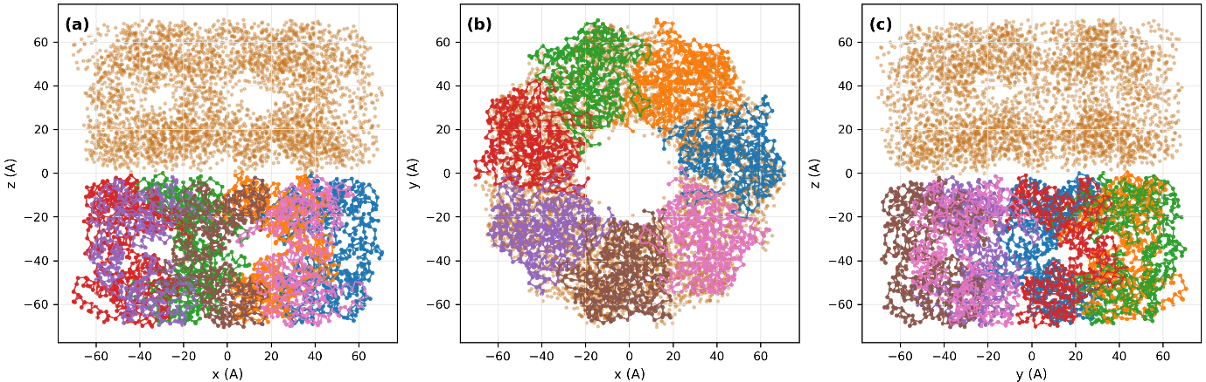
- Structural input used for GroEL density-model construction. C-alpha coordinates from public PDB structure 1SS8 are shown for the original C7 heptamer and the BIOMT-generated copy used to construct the D7 tetradecamer. The left panel overlays the original heptamer and BIOMT copy in an x-z view, and the middle and right panels show orthogonal x-y and y-z projections of the tetradecamer preview. Chain-colored traces identify the original heptamer, while the semi-transparent brown points indicate the BIOMT-related copy. This panel documents the structural origin of the PDB-derived density model only; it is not an atomistic refinement, orientation assignment, or molecular-dynamics result.

Five isosurface levels were extracted at 10%, 30%, 50%, 70%, and 90% of the density maximum. Model A used the original C7 heptamer mesh. Model B was assembled as a D7 tetradecamer by appending the BIOMT-related copy using the transform (x, y, z) -> (x, -y, -z). This step reused mesh components rather than reconstructing the density from atoms for each biological assembly.
The 50% threshold tetradecamer mesh was used as the representative protein-scale mesh. Before decimation, this mesh contained 194,460 points and 388,976 cells, with volume 1,067,555.95 Å³. After quadric decimation to approximately 20% of the original mesh, it contained 38,868 points and 77,792 cells, with volume 1,067,383.05 Å³. Across the decimation summary, the median point ratio was 0.1999, the median cell ratio was 0.2000, the maximum absolute relative volume error was 1.57 x 10⁻³, and component count was preserved.
Projection-level behavior was evaluated by comparing layer-weighted mesh/stencil projections with the reference density projection. For the original mesh/stencil projection, the midpoint layer-weight method gave relative total error -2.445%, relative RMSE over reference RMS 3.201%, Pearson correlation 0.999291, and cosine similarity 0.999526. The decimated 80% quadric-reduction mesh gave nearly identical values: -2.493%, 3.219%, 0.999289, and 0.999524. These checks show that substantial mesh reduction preserved the projected-density quantities used by the low-q workflow.
- GroEL density, mesh, template-library, and control-comparison parameters. The table summarizes the PDB-derived density construction, element counts, density-grid settings, isosurface extraction, C7 and D7 mesh assembly, 50% threshold mesh sizes before and after decimation, template-library construction, and the paired protein-template-versus-radial-control comparison. The source data are provided with the supplementary data package.
Quantity | Value | Note
Source structure | PDB 1SS8 | Public GroEL structure
Non-hydrogen atoms | 27064 | Density input
Element counts | C=16765, N=4634, O=5525, S=140 | Non-hydrogen atoms
Density approximation | Wassmaier-Kirfel-type Gaussian scattering-factor terms | Atom-derived smooth density
Grid spacing | 1.0 Å | Density-grid construction
Smoothing sigma | 6.0 Å | Density-grid construction
Clipping radius | 3.0 sigma | Localized density accumulation
Density grid shape | 188 x 186 x 120 | Voxels
Grid float32 memory | 16.01 MB | Density array only
Expected electron total | 179402.484 | Atom-derived model
Grid-integrated electron total | 179402.327 | Density-grid integral
Isosurface-level | 10%, 30%, 50%, 70%, 90% of density maximum | Mesh extraction
Model A | Original 1SS8 chain A-G mesh | C7 heptamer
Model B | Append original heptamer mesh with BIOMT copy | D7 tetradecamer
BIOMT copy transform | (x, y, z) → (x, -y, -z) | Model B assembly
B 50% original mesh | 194460 points, 388976 Cells, volume 1067555.95 Å³ | Tetradecamer
B 50% decimated mesh | 38868 points, 77792 Cells, volume 1067383.05 Å³ | Quadric r80
Template variants | Dry tetradecamer, R35 polyprism, R55 polyprism | Template library
Representative D7 rotations | 143 | From 201 candidate rotations
Total GroEL templates | 429 | 3 variants x 143 rotations
Curated public shots | 76 | Experimental comparison
Real median log-correlation | 0.610956 | Protein-derived library
Control median log-correlation | 0.605896 | Radial-profile randomized control
Median score difference | 0.003249 | Real minus control
Real better control | 61 / 76 | Paired comparison

- ID57 fixed-library construction and radial-control scoring
The ID57 analysis used a fixed core-shell candidate library before any experimental-frame scoring was performed. The public CXI file contained 209 detector images of size 401 by 401 pixels. The metadata identified normal-incidence core-shell nanoparticle patterns measured at LCLS on 2013-06-13, with detector distance 0.565 m, photon energy approximately 6023 eV, wavelength 0.205849 nm, pixel size 0.00010992 m, reconstructed q values up to 1.6777 nm⁻¹, and median positive total intensity 4,985,629 in the CXI data units.
The outer particle was represented as a Pd cube shell with side length 52.0 nm, and the inner core was represented as an Au octahedron with vertex radius 26.2 nm. The relative density contrasts were 1.0 for the Pd shell and 1.5 for the Au core. The simulation used the public detector geometry, a 384-pixel projected-density grid, a projection extent of 144.0 nm, a depth extent of 120.0 nm, 256 depth steps, and a constant synthetic-image background of 8.0 ADU. These model and simulation parameters were fixed before experimental retrieval and were not adjusted for individual public frames.
The structured template library contained 240 symmetry-aware orientations. Sampling used a Halton quasi-uniform spherical cap with roll sampling, maximum tilt 8 degrees, and symmetry reduction for the proper octahedral/cubic group. The symmetry group size was 24, and the roll angle was restricted to the representative range from 0 to 90 degrees.
- Fixed ID57 template-library and retrieval-control parameters. The table lists public detector metadata, fixed candidate-model parameters, simulation-grid settings, orientation-library settings, synthetic self-retrieval results, and paired structured-versus-control retrieval statistics. The source data are provided with the supplementary data package.
Quantity | Value | Note
Dataset | CXIDB ID 57 normal-incidence nanoparticle patterns | Public CXI input
Experimental frames | 209 | Public frames scored in retrieval
Detector image size | 401 x 401 pixels | Public CXI detector array
Wavelength | 0.205849312 nm | Public metadata
Detector distance | 0.565 m | Public geometry
Pixel size | 0.00010992000 m | Public geometry
Target positive total intensity | 4985629 | Median public-frame positive total
Candidate model | Outer Pd cube shell + inner Au octahedral core | Fixed template family
Outer cube side | 52.0 nm | Fixed before retrieval
Inner octahedral vertex radius | 26.2 nm | Fixed before retrieval
Relative density contrasts | rho_Pd=1.0, rho_Au=1.5 | Fixed before retrieval
Projection grid | 384 pixels | Simulation setting
Projection extent | 144.0 nm | Simulation setting
Depth extent and steps | 120.0 nm, 256 steps | Simulation setting
Background in synthetic generation | 8.0 ADU | Synthetic template generation
Orientation templates | 240 | Symmetry-aware library
Tilt limit | 8.0 degrees | Normal-incident orientation gap
Symmetry reduction | +z face representative; roll restrict to [0, 90 deg) | Octahedral/Cubic redundancy reduction
Synthetic self-retrieval accuracy | 1.000 | Noisy synthetic query vs clean library
Experimental paired comparisons | 209 | Structured vs radial control
Structured median log-correlation | 0.724752 | Experimental retrieval
Control median log-correlation | 0.443121 | Radial-profile randomized control
Median score difference | 0.283249 | Structured minus control
Structured better count | 209 / 209 | Paired sign comparison

The radial-profile-preserving randomized control was generated from the same structured template stack. Within the active annular retrieval ROI, template pixel values were randomly permuted inside one-pixel radial bins. This preserves the radial intensity distribution of each template but disrupts angular structure associated with the physical core-shell model. The structured and control libraries were scored against the same 209 public experimental frames using the same mask, annular ROI, log1p intensity transform, and per-template linear scale/background fit. The paired score differences therefore compare two libraries under matched preprocessing and scoring conditions.
Before experimental retrieval, the ID57 pipeline was checked with noisy synthetic queries generated from the same 240-orientation library. All 240 noisy synthetic queries retrieved the correct clean-template index, giving exact-index accuracy 1.0. The median log-correlation score was 0.966886, with minimum 0.956671 and maximum 0.969795. The median score margin between the best and competing templates was 0.013550. The raw quaternion error and the symmetry-aware octahedral error were both 0 degrees for the median, 95th percentile, and maximum.
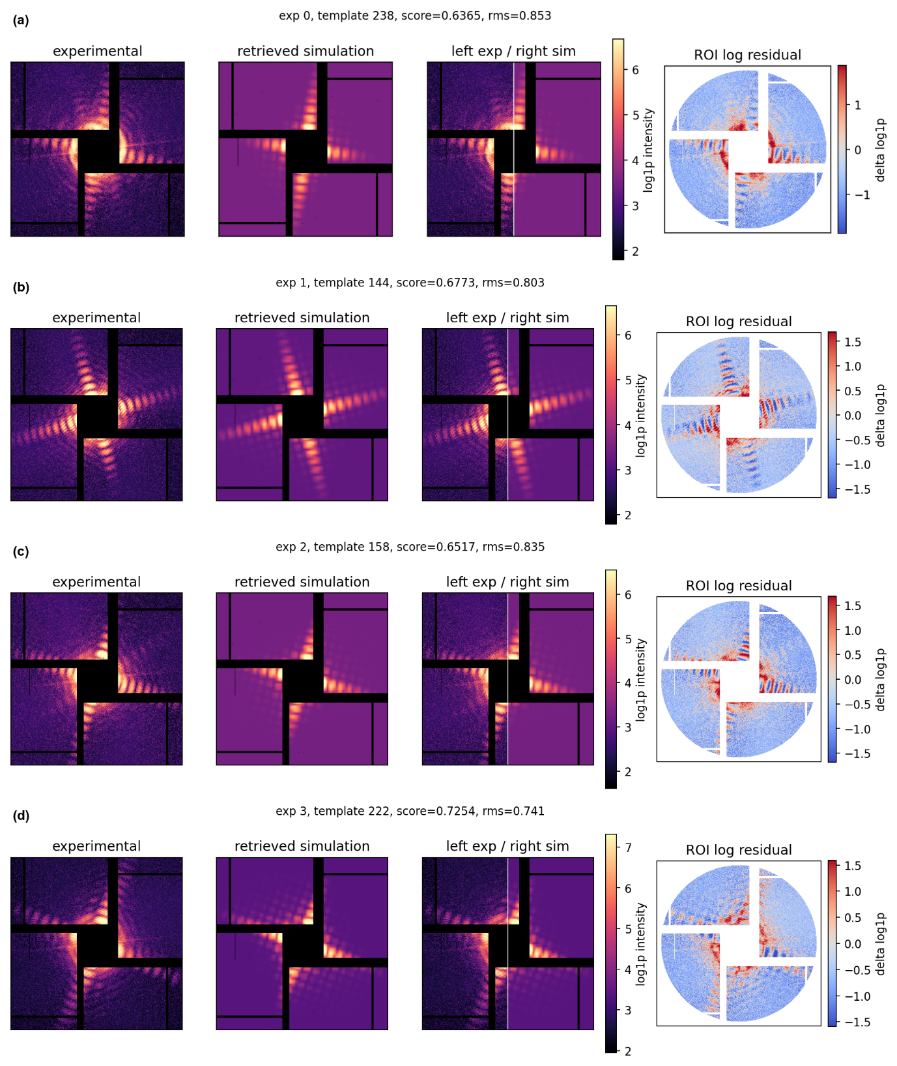
- Expanded representative ID57 retrieval examples. The main text shows a smaller representative panel for readability. This supplementary figure shows the expanded four-example panel, including experimental images, fitted structured templates, mixed experimental/simulation panels, and log-residual maps. The figure is intended as a visual check of the range of retrieved public-frame examples, not as proof of ground-truth orientation recovery.

- GroEL template variants and real-versus-control comparison
The GroEL template library used the D7 tetradecamer model and two coarse polyprism variants, R35 and R55. These variants were included to test whether coarse peripheral density changes could be propagated through the same projected-density template-generation workflow. They should not be interpreted as refined structural models. Symmetry-aware D7 sampling reduced 201 candidate rotations to 143 representative rotations. With three variants, the final GroEL library contained 429 templates.
The GroEL template geometry used a 128 by 128 downsampled detector image, an annular ROI from 5 to 40 pixels, projection pixel size 1.0 A, and FFT size 2048. These settings were chosen for a compact public-shot comparison rather than for high-resolution protein structure recovery.
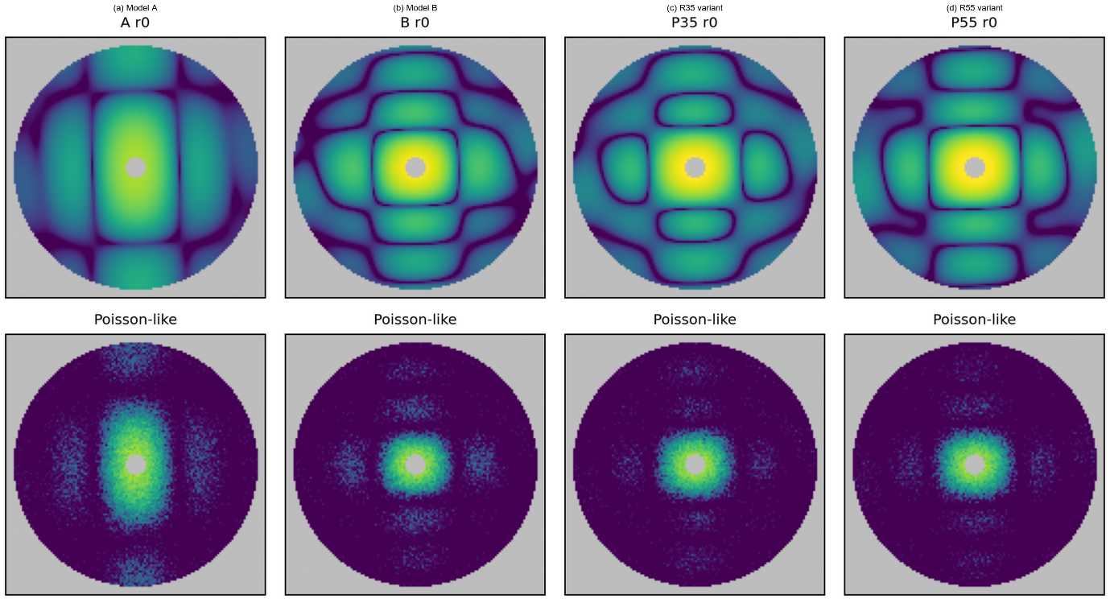
- GroEL model variants and preview diffraction patterns. The top row shows projected-density templates for one representative rotation (r0) of the dry Model A heptamer, dry Model B tetradecamer, and two coarse D7 polyprism variants with peripheral radii R35 and R55. The bottom row shows corresponding Poisson-like display realizations generated from the same simulated intensities. These panels are preview calculations for template-library inspection and are not fits to experimental GroEL shots. They show that the PDB-derived and coarse-variant models can be propagated through the same projected-density and detector-plane simulation workflow, while the most visible differences remain concentrated in the low-q radial envelope and coarse angular features.

The public experimental comparison used 76 manually curated GroEL shots. The protein-derived library had a median log-correlation score of 0.610956, while the radial control had a median of 0.605896. The median paired difference was +0.00325, with the real library better in 61 of 76 comparisons. The fit-RMS comparison was also slightly favorable: the real template median fit RMS was 1.8573, the control median was 1.8674, and the real library had lower RMS in 70 of 76 comparisons.
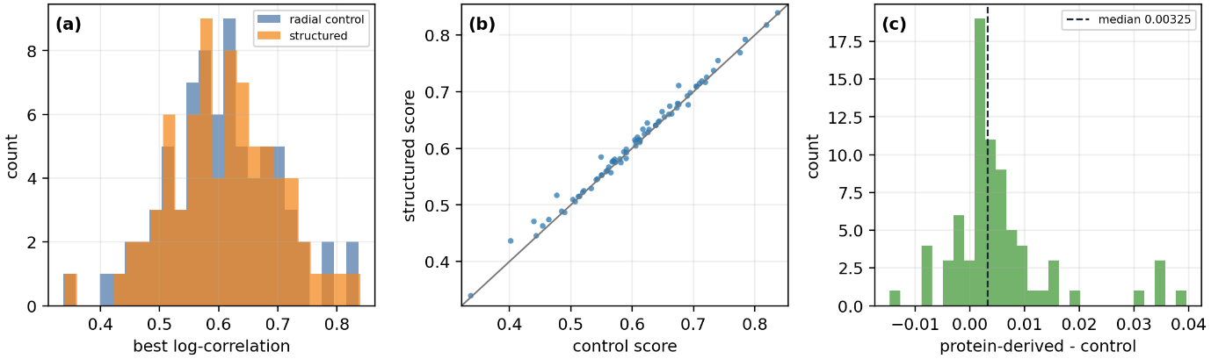
- GroEL protein-template versus radial-control comparison for curated public shots. The comparison uses the same public-shot set, annular ROI, log1p intensity transform, scale/background fitting, and scoring procedure for the protein-derived library and the radial-profile randomized control. The small but consistent separation supports the interpretation that the GroEL case demonstrates protein-density modeling and template-generation feasibility, but it is not a high-confidence single-shot orientation-retrieval benchmark. The source data are provided with the supplementary data package

- Benchmark environment and detailed timing scope
The benchmark study used the same public-safe scope as the numerical validation. The morphologies were synthetic or analytical objects: a sphere, an ellipsoid, a two-droplet composite object, an icosahedron, and a Gaussian-blob scalar-field object. Private deformation classes, experimental detector frames, detector masks, and beamline geometry files were excluded from the benchmark set.
The full benchmark used the signed_raster_gpu projection backend. The environment used Python 3.12.13, NumPy 2.0.2, SciPy 1.16.3, Open3D 0.19.0, CuPy 14.0.1, and a Tesla T4 GPU with 14,912 MB of memory. Each timing condition used two warm-up evaluations followed by five measured repeats. Unless otherwise stated, representative single-pattern benchmarks used a 512 by 512 projected-density image and a 257 by 257 detector-plane q-grid.
The q-grid size of 257 was chosen deliberately rather than using an even grid such as 256. Because 257 is odd, the reciprocal-space grid includes an exact central q=0 sample. This retained A(0,0) in the standard benchmark outputs and allowed projected-volume conservation to be checked from the relation between zero-frequency amplitude and projected mass. The same convention was used in the transform-normalization validation.
- Benchmark environment and timing-scope summary. The table lists the projection backend, GPU model, GPU memory, warm-up and repeat counts, and the number of rows included in the projection-scaling, q-grid-scaling, orientation-library, mesh-generation, and memory-comparison output summaries. The source data are provided with the supplementary data package.

Item | Value
Projection Backend | Signed raster GPU
GPU | Tesla T4
GPU memory / MB | 14,913
Timing warmup / repeats | 2 / 5
Projection scaling rows | 21
q-grid scaling rows | 6
Orientation library rows | 25
Mesh generation rows | 7
Memory comparison rows | 16

Single-pattern timing separated the projected-density rasterization step from the CZT detector-plane transform. For the sphere model with 36,480 faces, a 256 by 256 projected-density image and 257 by 257 q-grid required a median total time of 12.66 ms, or 78.99 patterns per second. At 512 by 512 pixels, the median total time was 26.01 ms, or 38.45 patterns per second. At 1024 by 1024 pixels, it was 87.89 ms, or 11.38 patterns per second. For the same image sizes, the median projection times were 5.45, 10.09, and 30.73 ms, and the corresponding CZT times were 7.15, 15.98, and 57.16 ms.
At the standard 512 by 512 projected image and 257 by 257 q-grid setting, the other morphologies showed similar single-pattern timing: 26.35 ms for the ellipsoid, 24.39 ms for the two-droplet object, 33.52 ms for the icosahedron, and 27.16 ms for the Gaussian-blob object. These values are hardware- and implementation-dependent, but they document that representative single-pattern generation was in the tens-of-milliseconds range on the tested GPU system.
The q-grid benchmark fixed the projected-density image size at 512 by 512 pixels and varied the reciprocal-space output grid. For the sphere, increasing the q-grid from 129 by 129 to 257 by 257 and 513 by 513 changed the median total time from 23.28 ms to 25.27 ms and 37.47 ms. The corresponding CZT time increased from 12.78 ms to 15.27 ms and 27.58 ms, while projection time remained near 10 ms. The Gaussian-blob model showed the same pattern: total time increased from 21.65 ms to 25.42 ms and 37.74 ms, while CZT time increased from 11.84 ms to 15.64 ms and 28.19 ms.
Mesh-complexity scaling was measured using sphere meshes of increasing resolution at fixed detector and q-grid sizes. At 512 by 512 pixels and a 257 by 257 q-grid, meshes with 224, 960, 3,968, 16,128, and 36,480 faces all produced median total times between 23.57 ms and 24.99 ms. Increasing the mesh to 65,024 faces raised the median total time to 34.56 ms. These results indicate that total runtime depends on mesh size, projected pixel coverage, rasterized triangle fragments, detector image size, and CZT output size, rather than face count alone.
Orientation-library generation repeats projection and transform evaluations over many orientations. For 1,000-orientation libraries, all five benchmark morphologies completed without failed orientations. The total wall-clock time was 154.54 s for the sphere, 157.77 s for the ellipsoid, 159.97 s for the two-droplet object, 151.31 s for the icosahedron, and 154.39 s for the Gaussian-blob object. The corresponding end-to-end throughput was approximately 6.25 to 6.61 patterns per second. For the same 1,000-orientation sphere benchmark, the summed projection time was 10.29 s and the summed CZT time was 16.63 s, while the measured wall-clock time was 154.54 s. The gap identifies Python-loop overhead, per-orientation setup, result handling, GPU synchronization, and other orchestration costs as optimization targets.
Mesh generation was benchmarked separately because it is usually a per-model rather than per-orientation cost. Direct analytical and component-based meshes were inexpensive: 1.11 ms for the sphere, 2.07 ms for the scaled ellipsoid, 1.16 ms for the two-droplet component assembly, and 1.18 ms for the predefined icosahedron topology. Scalar-field-derived objects were more expensive but still practical at the tested sizes: a Gaussian-blob density field sampled on 80 by 80 by 80, 120 by 120 by 120, and 160 by 160 by 160 grids and extracted using VTK Flying Edges required 12.43, 36.33, and 79.86 ms, respectively.
The memory comparison in the main text follows directly from storage scaling. A dense three-dimensional voxel representation scales as O(N³), whereas the projected-density image scales as O(N²). For a 512 grid, a dense float32 voxel volume requires 512 MB and a dense complex64 volume requires 1,024 MB. In contrast, a 512 by 512 projected float32 image requires 1 MB and a projected complex64 image requires 2 MB. For a 1024 grid, the dense float32 and complex64 volumes require 4,096 MB and 8,192 MB, while the projected float32 and complex64 images require 4 MB and 8 MB. Estimated mesh-array memory was 5.72 MB for 100,000 faces and 50,000 vertices, and 17.17 MB for 300,000 faces and 150,000 vertices.

- Interpretation of supplementary material
The supplementary figures and tables are intended to document reproducibility and provide visual context. They do not change the interpretation of the main results. ID57 remains the stronger public-data retrieval-oriented validation because the structured core-shell library clearly outperformed the radial-profile randomized control. GroEL remains a protein-density modeling and scalability demonstration because the real-versus-control separation was small, even though it was consistently favorable to the protein-derived templates. The benchmark details document the tested implementation and hardware environment; they should be read as evidence for practical throughput and memory scaling in this implementation, not as universal hardware-independent speed claims.

